**Lab Tasks**

**By**

**Alishba Waqar (46997)**

**Submitted to**: Ma’am Kausar

**Subject**: Operating System

**Date**:10/7/2024

**BSCS SEMESTER – 5**

**RIPHAH INTERNATIONAL UNIVERSITY**

**ISLAMABAD, PAKISTAN**

**Can you provide a detailed guide for each Linux command that includes screenshots and different examples beyond what has been taught? Additionally, can you identify each symbol and explain why it is used? Please explain each step one by one for every command.**

**Mkdir:**

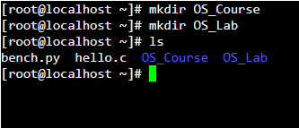

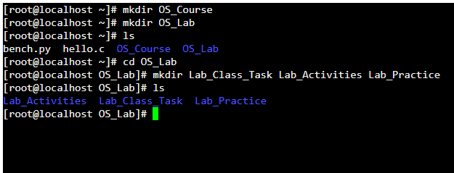

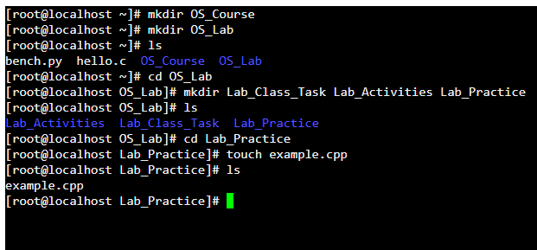



**Absolute Path:**

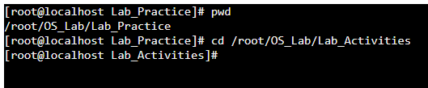

**Relative Path:**

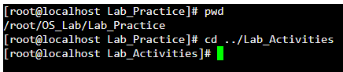

**Make following directory:**

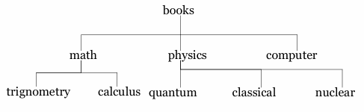

**Solution:**

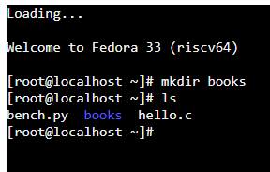

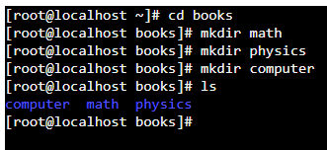

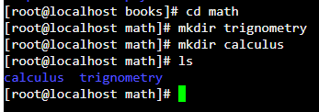

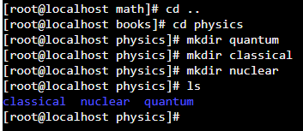

1. **mkdir: Create a new directory**

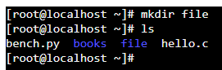

1. **rmdir: Remove an empty directory**

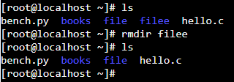

1. **cd: Change directory**

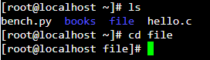

1. **cd/: Go to home directory**

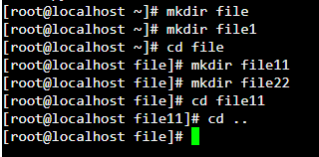

1. **pwd: Present working directory**



1. **ls: List directory contents**

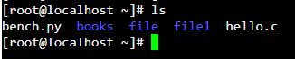

1. **mv: Move or rename files and directories**

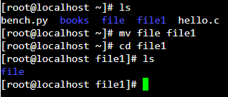

1. **cp -r: Copy files and directories**

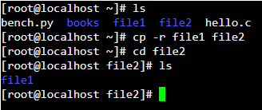

1. **rm -r: Remove directories (if directory is not empty)**

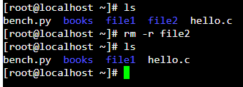

1. **ls -r: show list of directories in reverse**

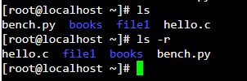

1. **ls -a: show hidden files also of that directory**

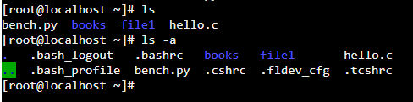

1. **ls -l: show all details list of files**

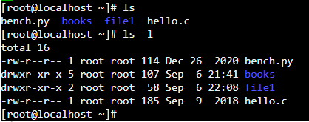

1. **touch: to create an empty file**

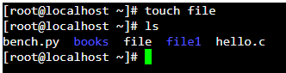

1. **cat > file: create file and gave us space to write data in that file**

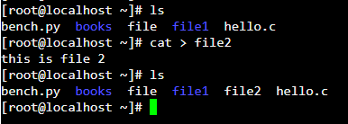

1. **cat file: read data from that file**

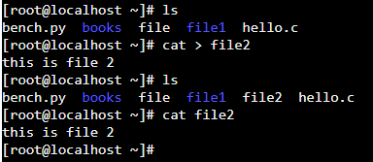

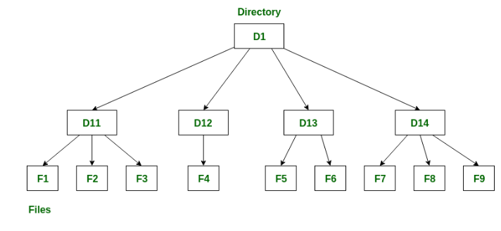

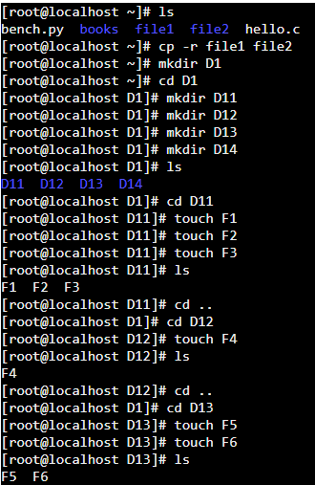

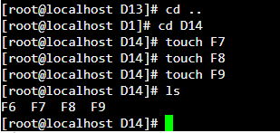

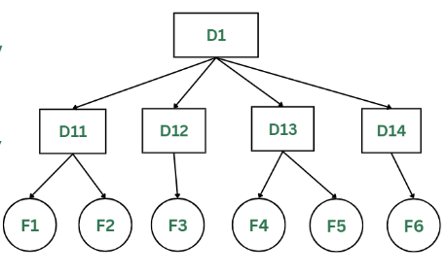

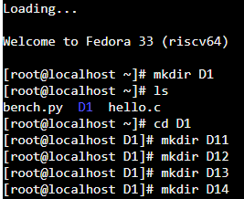

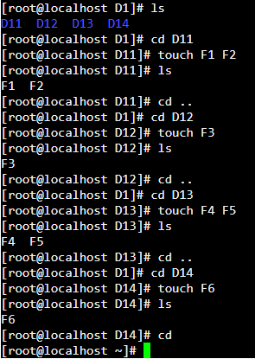

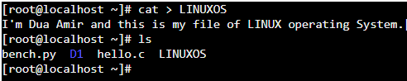

**Symbolic method:**

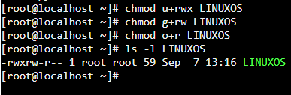

**Numeric method:**

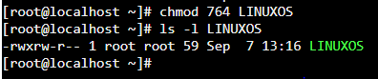

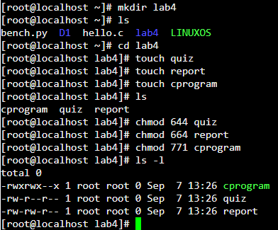

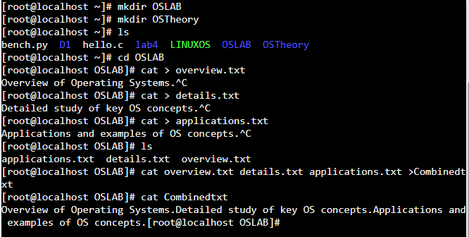

**Use of Touch:**

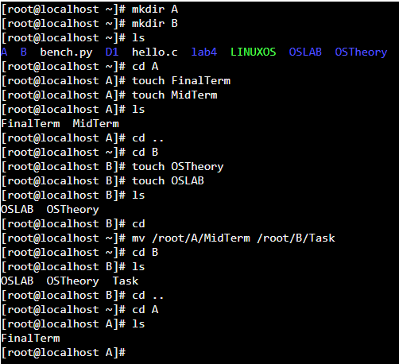

**Use of nano:**

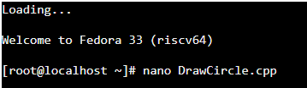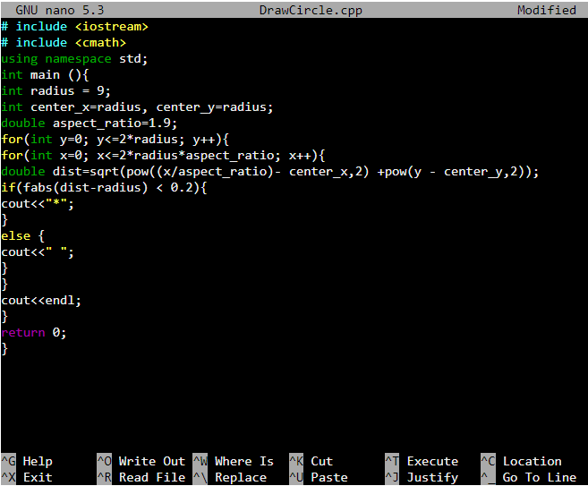

Exit

Yes

Enter

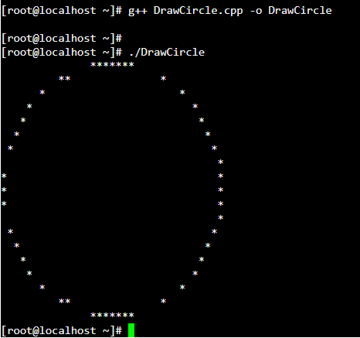

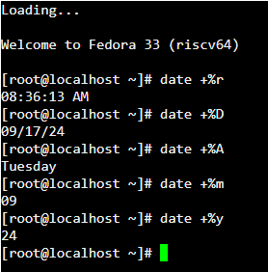

**Hours and Minutes:**



**Date in years:**



**Complete Time:**



**Yesterday date:**



**Tomorrow date:**



**10 days ago date:**



**Calendar:**

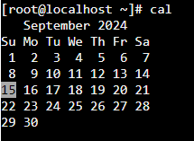

**Calendar of specific month:**

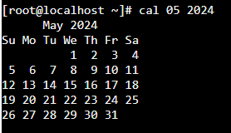

**Welcoming message:**

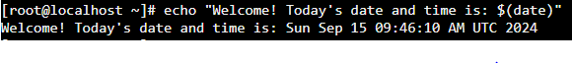

**Clear:**



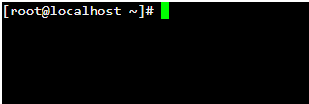

**Reverse a file:**

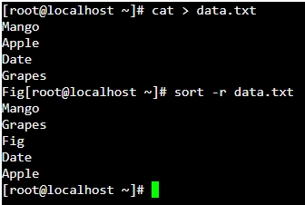

**Sort in column vise:**

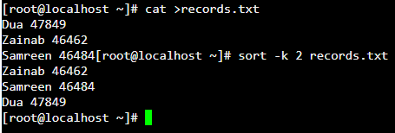

**Command to run a C++ File:**



By above command, a file created. To execute that file, we just write following command.

./tap

**-O:**

By using -o option, we name our program’s output file.



**Compile a C++ program:**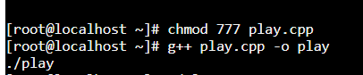

**Run a program:  
./play**

**Templates in C++ in Linux**

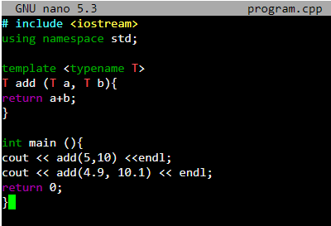

**We use following command to make a file executable:**  


**Redirections and Pipe operators:**

